Clean Code Principles - Keep It Simple (KISS)
# Source: AI Source: Provided by: [Data Path: Persons Table -> ID Column: 1, Name_En Column: Motasem Essam] -> From: [Chatgpt (GPT‑5 Mini)] on [12/9/2025]
The KISS principle (Keep It Simple, Stupid) means you should always prefer simple, clear, and straightforward solutions over complex ones.

🔑 Why KISS Matters
# Source: AI Source: Provided by: [Data Path: Persons Table -> ID Column: 1, Name_En Column: Motasem Essam] -> From: [Chatgpt (GPT‑5 Mini)] on [12/9/2025]
- Simple code is easier to read and understand
- Easier to maintain and modify
- Fewer bugs and edge cases
- Faster development and debugging

✅ Good Example
# Source: AI Source: Provided by: [Data Path: Persons Table -> ID Column: 1, Name_En Column: Motasem Essam] -> From: [Chatgpt (GPT‑5 Mini)] on [12/9/2025]
Simple and clear logic:
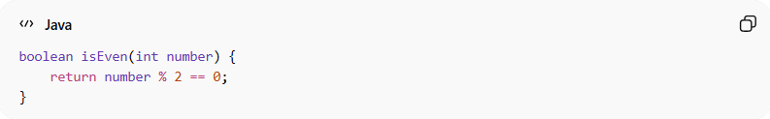
boolean isEven(int number) {
return number % 2 == 0;
}

❌ Bad Example
# Source: AI Source: Provided by: [Data Path: Persons Table -> ID Column: 1, Name_En Column: Motasem Essam] -> From: [Chatgpt (GPT‑5 Mini)] on [12/9/2025]
Overcomplicated solution for a simple problem:
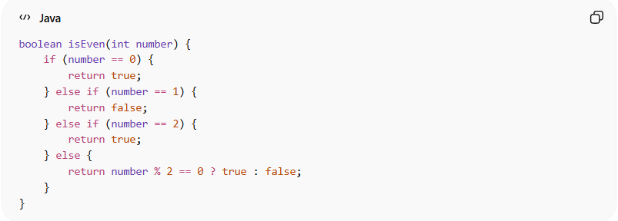
boolean isEven(int number) {
if (number == 0) {
return true;
} else if (number == 1) {
return false;
} else if (number == 2) {
return true;
} else {
return number % 2 == 0 ? true : false;
}
}

❌ Another Bad Example (Unnecessary Abstraction)
# Source: AI Source: Provided by: [Data Path: Persons Table -> ID Column: 1, Name_En Column: Motasem Essam] -> From: [Chatgpt (GPT‑5 Mini)] on [12/9/2025]
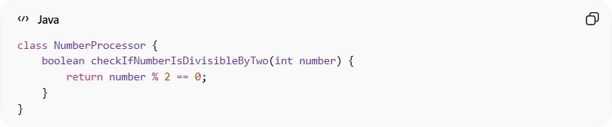
class NumberProcessor {
boolean checkIfNumberIsDivisibleByTwo(int number) {
return number % 2 == 0;
}
}

The class adds no real value
- The class NumberProcessor doesn’t store data
- It doesn’t group complex logic
- It only wraps a very simple operation
👉 So the class itself is unnecessary

The method name is too long for a simple task
checkIfNumberIsDivisibleByTwo
👉 This is:
- Verbose
- Harder to read quickly
- Not improving clarity much beyond a simpler name

The logic is already simple
number % 2 == 0
👉 This is already:
- Clear
- Short
- Self-explanatory
So wrapping it like this doesn’t make it better—it makes it heavier

👉 Overly verbose and unnecessary abstraction for a simple task.

💡 Key Idea
# Source: AI Source: Provided by: [Data Path: Persons Table -> ID Column: 1, Name_En Column: Motasem Essam] -> From: [Chatgpt (GPT‑5 Mini)] on [12/9/2025]
Simplicity is not about writing less code—it’s about writing clear and understandable code.

🚫 Common KISS Violations
# Source: AI Source: Provided by: [Data Path: Persons Table -> ID Column: 1, Name_En Column: Motasem Essam] -> From: [Chatgpt (GPT‑5 Mini)] on [12/9/2025]
- Overengineering solutions
- Adding unnecessary layers or abstractions
- Writing overly clever or tricky code
- Solving problems that don’t exist yet

🧾 Summary
# Source: AI Source: Provided by: [Data Path: Persons Table -> ID Column: 1, Name_En Column: Motasem Essam] -> From: [Chatgpt (GPT‑5 Mini)] on [12/9/2025]
Following KISS helps you:
- Keep code clean and readable
- Reduce complexity and bugs
- Improve maintainability
- Focus on solving the real problem

